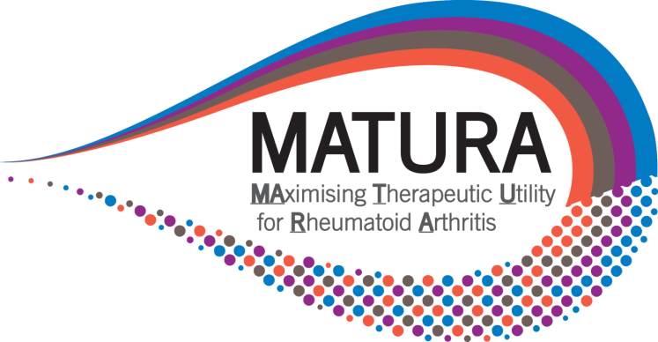

CONFIDENTIAL DISCLOSURE AGREEMENT

THE AGREEMENT is made on [Insert Date]
BETWEEN Queen Mary University of London an institute of higher education established by Royal Charter (RC000710) of Mile End Road, London, E1 4NS, England
(“SPONSOR”)

AND: [Insert Name]

RELATING TO: The MATURA Consortium where MATURA stands for ‘Maximising Therapeutic Utility for Rheumatoid Arthritis using Genetic and Genomic Tissue Responses to Stratify Medicines.

SPONSOR is in possession of valuable information, technical knowledge, experience and data relating to the Field, which may be regarded as assets of both scientific and commercial value.
SPONSOR is willing to disclose such information to the above named person on the condition that they do not disclose the same to any third party nor make use thereof in any manner except as set out below.

NOW IT IS HEREBY AGREED AS FOLLOWS:
- The above named person hereby agrees to keep all information supplied to or received by him relating to the Field, secret and confidential and not to divulge the same to any third party, nor make use of any such information without SPONSOR’s prior written consent.

- The above undertakings shall not apply to:

      - Information which at the time of disclosure is published or otherwise has been
made generally available to the public.

      - Information which after disclosure to is then published or made generally available to the public, otherwise than through any act or omission on the part of the above named person.

      - Information which can show was in the above named person’s possession at the time of disclosure and which was not acquired directly or indirectly from SPONSOR.

- The parties agree that after ten years from the date hereof, the above named person
shall be relieved from all obligations under this Agreement.

Signed: _________________________________
[Insert Name]
Position: Patient advisory Group (MPAG) member for MATURA
Date: ………………..



