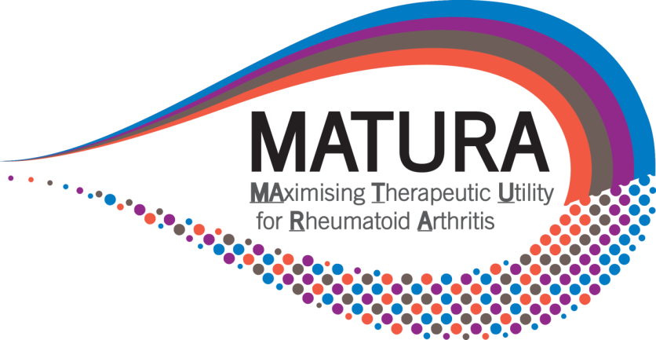




Maximising Therapeutic Utility for Rheumatoid Arthritis using genetic and genomic tissue responses to stratify medicines.
MATURA Patient Advisory Group (MPAG)
Remit, Role Description and Membership
MATURA is a nationwide group of academics, clinical consultants and industry groups who are jointly working towards developing tests and techniques to improve the diagnosis of Rheumatoid Arthritis and also to try and predict which patients might respond better to which treatments.
We are greatly committed to involving and engaging patients and the public with our work and so wish to invite interested parties to be a member of an advisory group and this role description and remit information should act as a guide for members to give you an idea about what this might involve. It explains what we would expect from you as well as what you can expect from us.
We hope to recruit 3-8 members. One of the main requirements for all members is an interest and enthusiasm about being involved in the research.
You do not need to have any previous experience of clinical research or the disease areas we specialise in. Although we hope that all members will be involved for approximately one year, you are free to withdraw at any time.
Your role may involve:
- Attending MPAG meetings. Frequency may vary and attendance can be via teleconference calls. Members will be asked to discuss and comment on the MATURA strategy, the STRAP clinical trial and the themes of work being undertaken - comments should aim to be representative of the wider patient community rather than commenting on issues which are entirely personal and not transferable.
- Reviewing, advising and feeding back on research documentation which may include lay summaries, patient information sheets, consent forms, newsletters, reports, amendments, promotional material and media articles.
- Advising on comprehensibility, language, presentation, justification, relevance and any other issue of importance raised by research material.
- Ensuring that the patient perspective is included in the MATURA strategy and research.
- Helping to disseminate research findings.
- Accepting and responding to email correspondence from the MPAG chair person.
- Dealing with associated paperwork and to read through before meetings.
- Training and development, where possible as requested.
Member specification:
Each member should:
- Have a musculoskeletal condition and/or care for someone who does and/or have an interest in musculoskeletal research.
- Be available to take part in MPAG meetings either in person or by teleconference and prepare appropriately e.g. reading of relevant material.
- Demonstrate a balanced, broad view of matters relating to the problems of people with musculoskeletal disorders.
- Be willing to look at a situation from different viewpoints.
- Be willing to take an active part in meetings.
- Be willing to listen to, read and assimilate information and weigh evidence.
- Maintain confidentiality, demonstrating tact and discretion.
Contact:
- Meetings will be held at Charterhouse campus of Queen Mary University or another convenient location. Members not in the immediate vicinity will be able to dial in to a teleconference link to partake. These will be informal and technical language or jargon will be avoided as much as possible.
- Members will be reimbursed any travel/dial in expenses.
- Members may be contacted by email, phone or post (members may express a preference) for their advice and feedback.
- Members will be invited to symposiums for MATURA, any open days, away days, other special events that will be show casing the work of MATURA. Attendance is optional.
Membership will be for one year on a rolling basis. Members will be free to withdraw at any time, but a year commitment (following an introductory meeting) would be preferable.
Members who miss 3 meetings in a row will be contacted by the chair of the group with the option of withdrawing membership or continuing.
Membership of the MATURA Advisory Group is voluntary, there is no fee payable for attendance other than travel/dial in costs.
Members will be expected to sign a confidentiality contract and have a duty to treat anything said/read in meetings as confidential in line with ethical guidelines.

Contact details:
- Chairperson for MATURA Advisory Group – Zoe Ide – Zide@independent-search.com
- Queen Mary University Hospital, Project Manager – Dr Michelle Korda – m.korda@qmul.ac.uk :Tel: 0207 882 3497
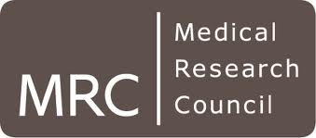

- University of Manchester, Project Manager – Deborah Maskell – Deborah.maskell@manchester.ac.uk :Tel: 0161 275 5046

